;;;;;;aaa

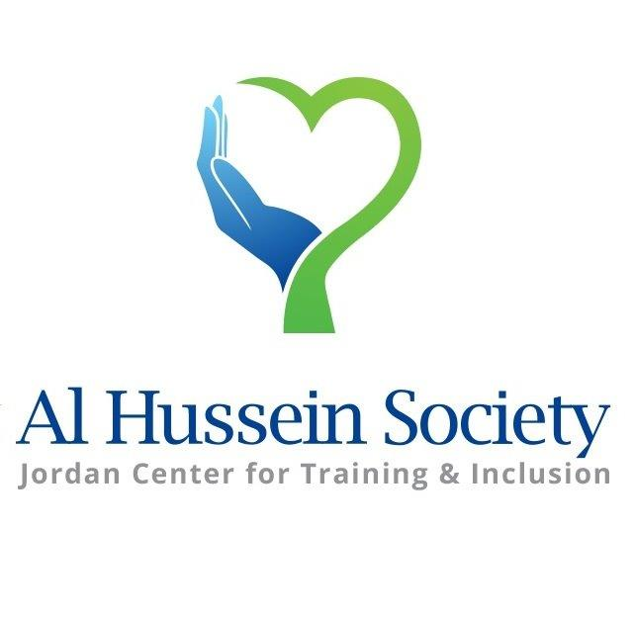

Al-Hussein Society

**Leave no one behind Inclusive Education & Mental Health**

Annual Report 2019

### **Table of Contents**

|  |  |
| --- | --- |
| Subject | Page |
| A Word from the President | 4 |
| Introduction | 5 |
| Comprehensive Rehabilitation Programs | 6 |
| Local and International Partnership and Agreements | 7 |
| Regional and International Development Projects | 9 |
| Local and International Exposure | 22 |
| Participation in Local and Regional Events | 22 |
| New Policies and Procedures | 25 |
| Statistical Report of Rehabilitation Programs | 26 |
| AHS Contribution for PWD on National Level | 37 |
| Future Plans | 38 |
| Acknowledgements | 38 |

## **Acronyms & Abbreviations used**

|  |  |  |  |
| --- | --- | --- | --- |
|  |  |  |  |
| AHS | AL-Hussein Society /Jordan Center for Training and Inclusion | **DTF** | Disability Task Force |
| PWDs | Persons With Disabilities | **HCD** | [Higher Council for the Rights of Persons with Disabilities](https://www.google.jo/url?sa=t&rct=j&q=&esrc=s&source=web&cd=1&cad=rja&uact=8&sqi=2&ved=0ahUKEwiWyuzT4azQAhVILhoKHUIpBq4QFgggMAA&url=http%3A%2F%2Fhcd.gov.jo%2Fen%2F&usg=AFQjCNF2N418Q64a57WzWyS0RqFsMQLJwg&sig2=PtXCU9jXsDbU2Q-XUs-gVA&bvm=bv.138493631,d.d2s) |
| ST | Speech Therapy | **MOE** | Ministry of Education |
| PT | Physio Therapy | **MOP** | Ministry of Planning |
| OT | Occupational Therapy | **EIP** | Early Intervention Program |
| MA | Mobility Aids | **OW** | Orthopedic workshop |
| O&P | Orthotic Braces and Prosthesis | **OCHA** | Office for the Coordination of Humanitarian Affairs |
| SE | Special Education | **CBM** | Christoffel-Blindenmission-Christian Blind Mission |
| CBR | Community Based Rehabilitation | **BMZ** | The Federal Ministry for Economic Cooperation and Development (Germany) |
| WHO | World Health Organization | **LDS** | The Center for Cultural & Educational Affairs for the Church of Jesus Christ of Latter-day Saints |
| IOCC | International Orthodox Christian Charities | **ILO** | International Labor Organization |
| ED | Executive Director | **CBID** | Community Based Inclusive Development |
| TOT | Training Of Trainers |  |  |

# A Word from our President

During 2019 Al Hussein Society, represented by its board members, management and technical staff, continued providing quality comprehensive rehabilitation services and training according to international standards while abiding by the national laws, regulations and strategies relevant to disabilities. This required following up on the latest development in the field of disabilities. For instance, according to recent studies, mental health services and assistive technologies have been identified as major gaps in the provision of comprehensive rehab services. AHS had to integrate these services into its programs, a fact that increased our financial burdens. Though we cannot but thank those who have given us their helping hands to overcome these challenges we had to think of activating our income generating projects including our vintage store “NEW To YOU” and Physiotherapy Center to be able to reach the most vulnerable people living in Jordan including refugees living in the camps and host communities.

I would like to convey my sincere gratitude to every single person with whose help we were able to reach more than four thousand persons with disabilities at the national level whether through providing institutional rehab services or reaching those, who cannot reach us through our mobile clinics.

With your continuous support, we look forward to pursue our mission in 2020 and become a center of excellence for others to follow in order to reach all those who are in desperate need to affordable quality rehab services at the national level.

Together we can do more and better!

HRH Princess Majda Raad

AHS Founder and President

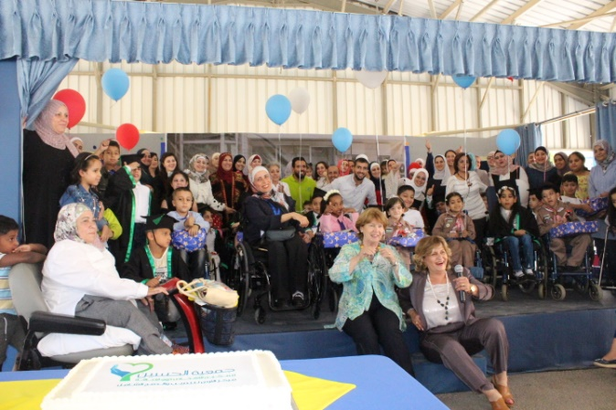

# Introduction

During 2019, Al Hussein Society faced a number of challenges, mainly due to the bad economic situation of the region, that effected in a decrease of the number of beneficiaries in comparison with the previous years; AHS did not receive sufficient financial support from both public and private sectors to cover its expenses and had to limit its programs to those sponsored by international organizations like OCHA, CBM and HELP. During 2019, AHS still succeeded in providing more than **4000** people with quality services, in addition to building the capacity of people working in the field of disabilities and enriching the already existing centers with new programs.

AHS, being aware of the urgent need for mental health services to complete its rehab programs, established partnership with the German HELP organization to introduce mental health services into AHS programs and advocate for these services to be integrated into the programs of the public primary health centers of the Ministry of Health at the national level.

One of the major achievements during 2019 is that AHS was able to approach OCHA (Office for the Coordination of Humanitarian Affairs) directly and get funds without the need to partner with other international organizations. This was the best indicator of the status AHS has reached as an institution that applies the work standards of international organizations.

The major policy of AHS is to follow the national strategy related to the rights of persons with disabilities. Inclusive education is one of the priorities of the national agenda. During 2019, AHS’s management and its multidisciplinary team has been revising all its programs to support inclusive education including school admission criteria. This required total separation between two major programs: Education and rehabilitation, while providing minimum required rehab services inside the school. In 2020, AHS will develop detailed work procedures for inclusive education including training packages to transfer knowledge.

Our financial constraints led AHS to think of activating the income generating projects according to the national rules and regulations. This required AHS to follow the work license of its new physiotherapy center that is open to the public to help us reach the most vulnerable children living in Jordan including refugees. This center has been equipped with the most advanced equipment and its staff received training in Germany before resuming their work.

Quality programs means evidence-based practices and this directed AHS to carry out research and studies together with two major universities; Jordan University and Jordan University for Science and Technology.

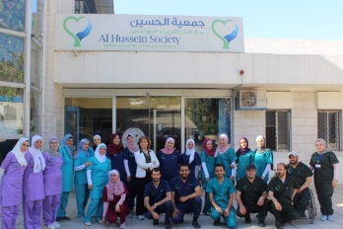To realize the goals of AHS, several procedures were consolidated and new ones were adopted in 2019 to upgrade the programs and ensure higher quality in an institutionalized and sustainable manner as follows:

# Comprehensive Rehabilitation Programs

Comprehensive rehabilitation services to persons with disabilities were further developed and upgraded in the following programs (See pages 24-35):

|  |  |
| --- | --- |
| Early Intervention Program (EIP) | Inclusion |
| Community Based and Outreach Rehabilitation | Occupational Therapy |
| Mobile Clinics | Hydrotherapy |
| Psycho-Social Counseling | Orthotic Braces and Prosthesis |
| Medical Clinics | Therapeutic Horse Riding |
| Nursing | Training |
| Nutrition | Physiotherapy |
| Speech Therapy | Mobility and Adaptation Unit |
| Mental Health |  |

# Local and International Partnerships and Agreements

**AHS continued to implement previous agreements and launched new ones with the following partners**:

# - The Higher Council for the Rights of Persons with Disabilities (HCD)

* AHS participated in every event organized by HCD to ensure that our programs abide by the national policies and strategies.
* ED attended Launching ceremony for the national plan of correcting building situations. The ceremony was organized by the Higher Council under the patronage of Prime Minster Dr. Omar Al-Razzaz.

# - The Ministry of Education

* Supported **60** AHS school students with an amount of JD 42,200.
* A workshop was held for school principals and educational counselors about integration, representing **37** mainstream schools where AHS children are integrated.
* Seconded **3** teachers to AHS school whose salaries are covered by MOE while AHS issued their bonuses.

# - The Ministry of Health

It continued seconding AHS with Rehab Doctor and Urologist.

* Requirements for licensing AHS OW and PT Center were followed up; a delegation from the Ministry of Health visited AHS to identify the requirements. Work License was issued for the PT center while the OW is still pending.
* The mutual agreement was renewed and new articles were added as an appendix to increase the number of seconded doctors and technicians.

# - The Ministry of Social Development

* AHS activities were implemented abiding to the rules and regulations of the Ministry of Social Development.

# - The Hashemite University

* AHS offered clinical training to **101** physiotherapy and occupational therapy students.
* AHS and Hashemite University signed an agreement to introduce CBR higher diploma developed by AHS at the Hashemite University. The program will start at the beginning of the second semester of the current academic year 2019-2020.

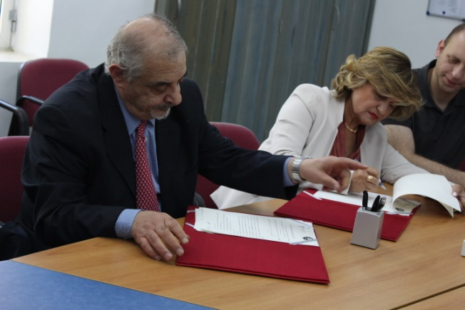

# The University of JORDAN

* AHS offered clinical training to **169** physiotherapy and occupational therapy students.
* Research Cooperation between University of Jordan and AHS “Activating the use of a medical record for children with cerebral palsy at AHS”.

# isra University

AHS was approached for the first time by the university to provide offered clinical training to their PT students on regular basis. **8** physiotherapy students received their training during 2019.

# Regional and International Development Projects

The Center for Cultural & Educational Affairs for the Church of Jesus Christ of Latter-day Saints (LDS):

**44** Wheelchairs were distributed to beneficiaries at AHS premises and through its mobile clinics in the community.

* Present LDS’s regional wheelchair responsible Mr. Mark A. Anderson visited AHS to study cooperation at the national level and for AHS to become their sole representatives in Jordan.
* Agreement was signed between AHS and LDS to provide AHS with **644** wheelchairs & **562** mobility aids (Walkers, Crutches) during 2019-2020.
* Partner Assessment of Al Hussein Society-2019; wheelchair service Assessment has been implemented by LDS and AHS performance has been rated 91.5 out of 100.
* Funding equipment for orthopedic workshop has been approved for the amount of JD 15,685. The purchase will be followed by AHS and LDS during 2020.

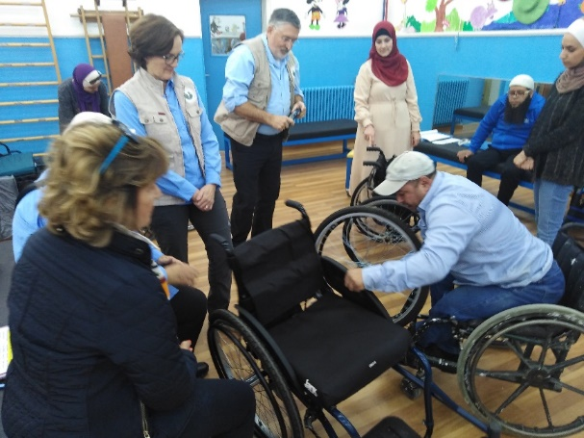

# - CBM continued to provide support for the establishment of the AHS Regional Training Center as follows:

* Quarterly, semi and annual statistical and narrative reports were prepared and submitted according to the rules and regulations of CBM.
* Workshops on inclusion were implemented addressing **21** caregivers of the school & EIP children.
* Two workshops on Child Safe Guarding. Guidelines were organized to **48** caregivers of the School & EIP children.
* Environment adaptations were made in **4** schools where AHS students were integrated.
* **18** of AHS senior staff attended two intensive courses on Assistive Technology conducted by internationally acknowledged experts as follows:

1. Better Quality of Life/Educational Solution – Educational System (SE.S); 7 days training for 16 of AHS staff from 19/5/2019 till 27/5/2019 conducted by UNDP accredited trainer from Cyprus.
2. Daily Life Skills and Accessibility conducted by Royability, Inc. Canada; 4 days training for 18 of AHS staff from 22/6/2019 till 25/6/2019.

During the 11 days intensive workshops AHS staff have managed to acquire a wide range of technical knowledge, practical skills, and showed positive attitude. They learned what AT is, they have justified in theory and in practice the importance of integration of AT in their everyday work at AHS. AHS staff have proceeded into learning a series of more than 60 tools (software and hardware).

* Three days intensive training course was held for **18** trainees (Jordanian) about CBR programs conducted by AHS trainer. The trainers focused on defining CBR program, the role of the community towards disability issues / the role of volunteerism / mechanism of the program application and implementation - CBR strategies – CBR matrix
* Mental Health & Rehabilitation Conference was organized and held on December 14th, 15th, and 16th under the Patronage of HRH Prince Raad Bin Zeid. 22 scientific papers were presented during the first day at Geneva Hotel followed with **5** specialized training workshops at AHS premises during the following two days. The conference was followed up by round table discussion on December 15th to work on the recommendations together with the speakers and potential partners working in mental health.
* 2020 budget plan was signed amounting to JD 35,376,77.
* **3** therapists, accountant and technician have been enrolled for English courses at AmidEast within AHS continuous capacity training programs.
* Project management courses have been planned for the senior staff members that will be held during the first quarter of 2020.
* AHS staff provided training on assistive technology to the participants of the International Scientific Conference in Special Education at the Hashemite University with the title "Knowledge content of persons with disabilities”. During the conference, ED presented a scientific paper on: Innovative Approach towards Inclusive Education: Leaving no one behind.

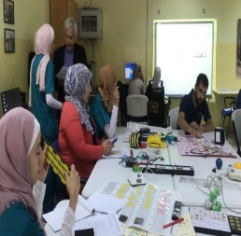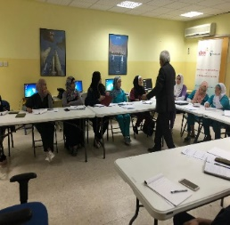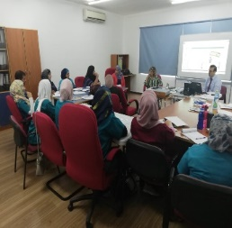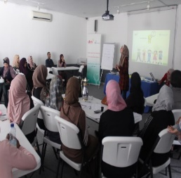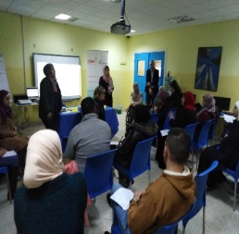

# BMZ - CBM: Provision of rehabilitation services for persons with physical disabilities in Jordan

* **During the three months of the project, the following achievements were accomplished**
* **120** Persons with disabilities (Syrians & Iraqi refugees and vulnerable Jordanians) were assessed and their mobility needs identified in Azraq camp, Ramtha, Maan and Amman. **108** persons received **250** mobility aids and orthotic devices.
* **95** university students have received training.
* AHS trainers conducted training workshop to **11** of HU graduate students (Queen Rania Faculty for Childhood) on environment adaptations and mobility aids.
* Clients satisfaction forms were filled as follows:

|  |  |
| --- | --- |
| Item | Number of questionnaires applied |
| Feedback Questionnaires: for beneficiaries who were serviced through receiving mobility aids | **210** |
| Feedback Questionnaires: to follow up to what extent the trainees applied the acquired skills | **90** |
| Feedback Questionnaires: to follow up to what extent the school staff trainees applied the acquired skills | **60** |
| Feedback Questionnaires: report to be better informed about their rights and duties as a result of the training | **191** |
| Feedback Questionnaires: for patients’ welcome of the equipment and accessibility of the centers as a positive development. | **57** |

**Final Narrative Report for the whole duration of the project was submitted to CBM**

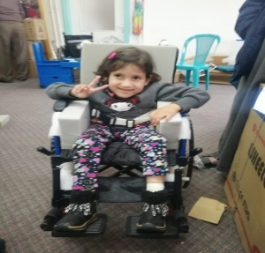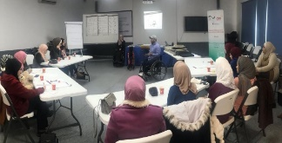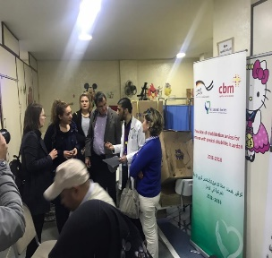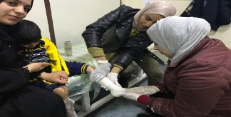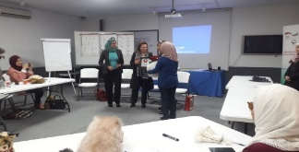

# Cbm - Empowerment of Syrian Refugees to create an inclusive society through Community Based Rehabilitation and Outreach programs

**During the six months of the project, the following achievements were accomplished**:

* **67** rehabilitation sessions (Physiotherapy / Occupational Therapy) for the beneficiaries.
* **33** psychological counseling sessions during home visits for the beneficiaries.
* **7** referrals were made to AHS workshop and one to the public health centers.
* (46) Persons received (83) adapted mobility aids.
* Maintenance of mobility aids and customized home-based rehabilitation exercises were conducted for the **35** beneficiaries.
* **9** houses and one work place in Amman and Irbid were adapted (environmental adaptation).
* **4** volunteers were trained through engaging in the community activities together with AHS team.
* **26** beneficiaries (PWDS & families) were educated about the rights of persons with disabilities during home visits.
* AHS project director and the project manager conducted meeting with (five) members of Syrian participant living in the North and Tamkeen’s Society Director within the project activity requirements for DPOs formation.
* Inclusive sporting events were conducted for 72 youths with and without disabilities: (5) AHS School students, (24) public’s elementary school, (8) AHS graduates, (15) youth group, and (20) AHS workers.
* 20 local health workers (e.g. primary health care personnel), clinic personnel on birth impairments (early identification and referral) were educated on the rights and needs of people with disabilities and their families at Al Helel health medical center.
* A meeting was held for parents and teachers at the Al-Hussein Society on the subject of integration into society and schools for people with disabilities to establish a parents and teachers council.
* Feedback Questionnaires for beneficiaries who were served through receiving mobility aids and rehabilitation sessions were followed. Analysis of the results of the questionnaires was prepared.

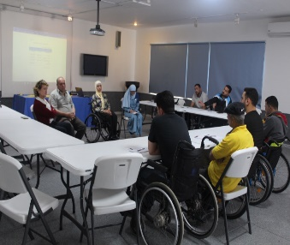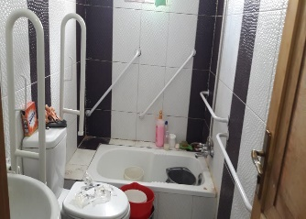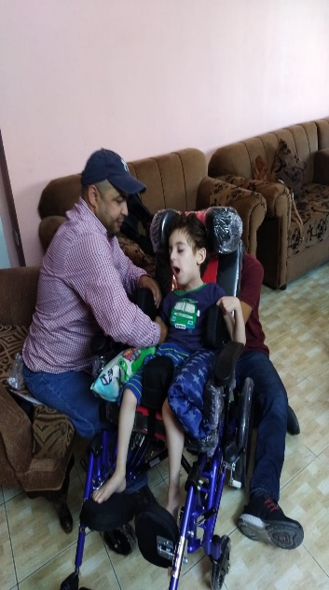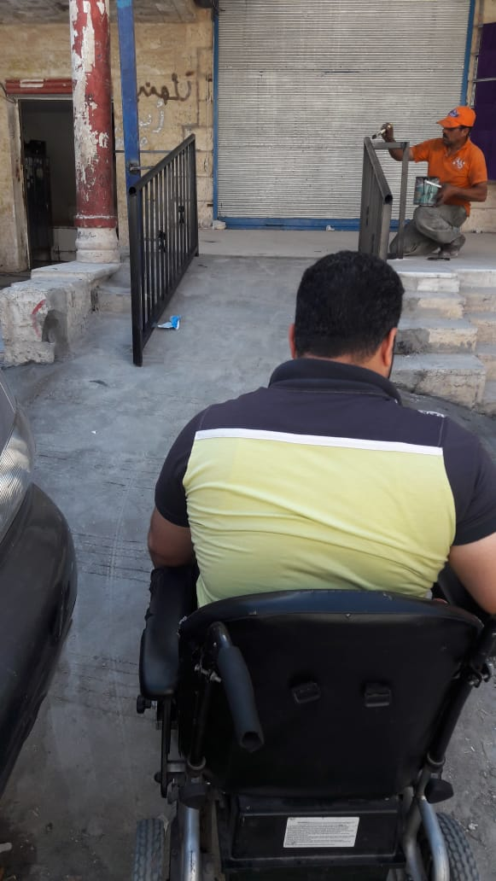

# OCHA -PROJECT: INCREASE access to rehabilitation services for marginalised people & children with disabilities and their families in Azraq Camp, ZARQA, Ma'an and Tafileh Governorates

* **145** Persons with disabilities (Syrians refugees and vulnerable Jordanians) were assessed and their mobility needs identified in Azraq camp, Zarqa, Maan and Al Tafeleh. **140** persons received **299** mobility aids and orthotic devices.
* **76** physiotherapy and occupational therapy services were provided.
* **8** psychological counselling were provided. **2** psychological support groups were conducted for 13 caregivers (females).
* **13** persons with disabilities and their families have received training at home and rehabilitation sessions during 3 months. They gained the skills and knowledge how to treat their PWDs.
* **8** referrals were made to AHS workshop and to the public health centers.
* A group of donors accompanied by the RCHC and OCHA Head of Office visited Hussein Society Mobile Clinics in the field, along with house visits to the beneficiaries of the project.
* **Four raising awareness workshops were held as follows :**

1. Workshop was held in Azraq camp in coordination with UNHCR, NHF, and CARE to raise awareness on the CRPD and the needs and rights of persons with disabilities. 90 persons with disabilities, caregivers, (refugees) and people without disabilities have received training about the rights and interests of people with disabilities.
2. Workshop was held in Al Rseifeh in coordination with two local societies (Zhour Alward & Knmana for disabilities) to raise awareness on the CRPD and the needs and rights of persons with disabilities. 39 persons with disabilities, caregivers, (Jordanian citizens & Refugees) and people without disabilities have received training about the rights and interests of people with disabilities.
3. Workshop was held in Al Hsyneyeh/Maan Governorate in coordination with Al Hsyneyeh Society & Social Development Directorate to raise awareness on the CRPD and local lows and legislations, rights of persons with disabilities and the needs. **64** persons with disabilities, caregivers, and people without disabilities have received training about the rights and interests of people with disabilities.
4. Workshop was held in A Hassa / Al Tafeleh Governorate in coordination with (Saydat Al Njmat Society) & Social Development Directorate to raise awareness on the CRPD and local laws and legislations, rights of persons with disabilities and the needs. 45 persons with disabilities, caregivers, (Jordanian citizens & Refugees) and people without disabilities have received training about the rights and interests of people with disabilities.

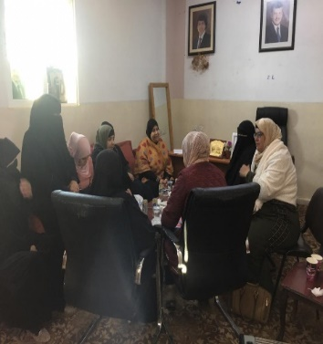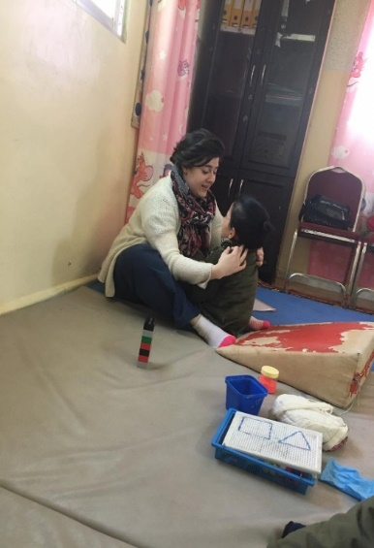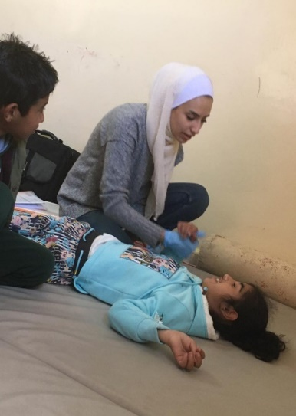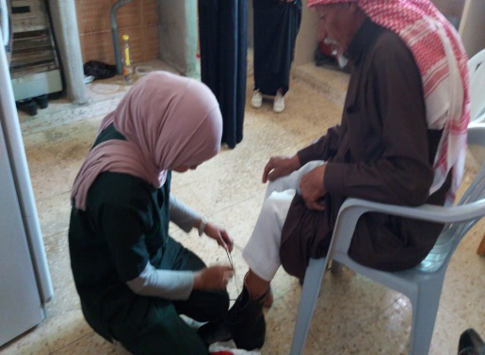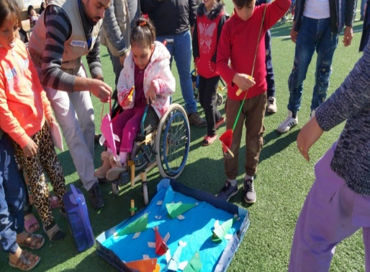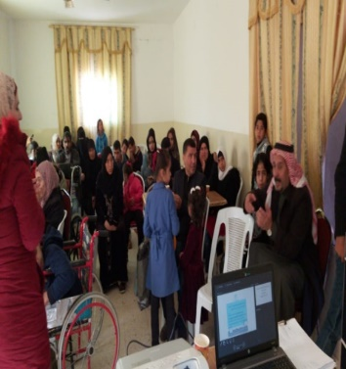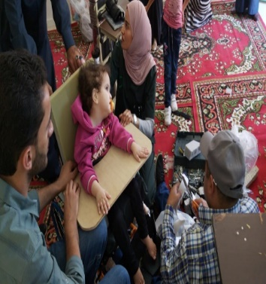

# Help-Project: Creation of sustainable structures for the psychosocial treatment of Syrian refugees in Jordan (Balsam Project)

* An approval has been received by BMZ for HELP to hand over the project to AHS as from July 2019. This project was implemented by the psychosocial department who were trained by psychiatrists and psychologists. Plans were made to continue training AHS team by Charite hospital in Berlin during second quarter of 2020.
* Provided dispensing medications & psychological rehabilitation sessions for **1761** beneficiaries in **Sahab** , **Zarqa** & **Al-Mafraq**
* AHS psychologists were trained on psychological counseling skills in the **3** clinics in **Sahab**, **Zarqa** & **Al-Mafraq** with a total number of 36 visits for each.
* Meetings were held between AHS Executive Director and Mr. Kayu Orellana and Ms. Christina, Mental Health & Psychosocial Support Delegate/International Committee of the Red Cross (ICRC) to discuss future cooperation.
* ED and AHS staff designed Mental Health Awareness Campaign strategies using social media.
* AHS staff prepared messages for campaign.
* AHS Executive Director (Project Director) formed organizing committee from academics in the field of rehabilitation consisting of Dr. Hikmat Hadoush, (PHD in Neuro rehab and Dr. Maher Assasleh, Psychiatrist, headed by AHS executive director.
* AHS strategic marketing partner TACTIX, prepared the design of the posts of the conference, workshops and the projects that were published in social media and AHS official website.
* An interview was organized between one of the leading daily local newspapers to announce for the conference, attract academics and field workers to submit papers and projects in addition to raising the awareness of the communities in the field of Mental Health.
* Project director was interviewed by Amman TV to speak about introducing mental health services into AHS programs.
* **6** support groups were conducted, and the training included the following:

1. Express themselves and emotions.
2. Appreciate themselves.
3. Communicate with others positively.
4. Individual meetings with children were held to discuss their problems and train them on problem solving skills.
5. Physical therapists of AHS, university students and psychosocial did a fun activity to boost children’s self-esteem.
6. AHS occupational therapists do stress relief sessions through fine skills such as quilling, painting, drawing and sewing.

* **3** workshops were carried out by AHS psychologists as a part of training for Syrian refugees (Mental Health Awareness).
* e-learning platform was activated as follows :
* An online platform for training and further education has been set up.
* Online platform is available in 2 languages, English and Arabic.
* It was activated on AHS’s website.
* It was also published on Facebook via AHS page also the conference’s page.
* Mental Health & Rehabilitation Conference was organized and held on December 14 & 15& 16 under the Patronage of HRH Prince Raad Bin Zeid. **22** scientific papers were presented during the first day at Geneva Hotel followed up by **5** specialized training workshops at AHS premises during the following two days.
* The conference was followed by round table discussion on December 15th to work on the recommendations together with the speakers and potential partners working in mental health.

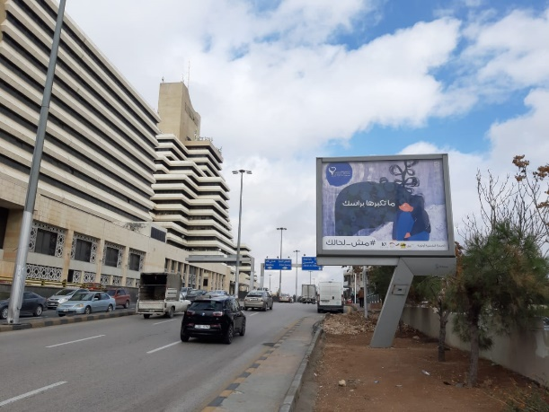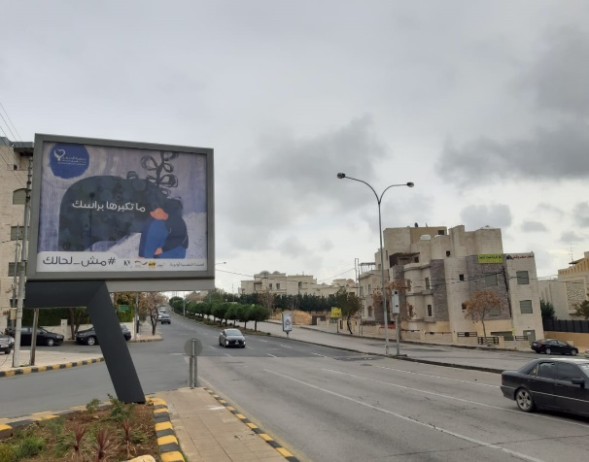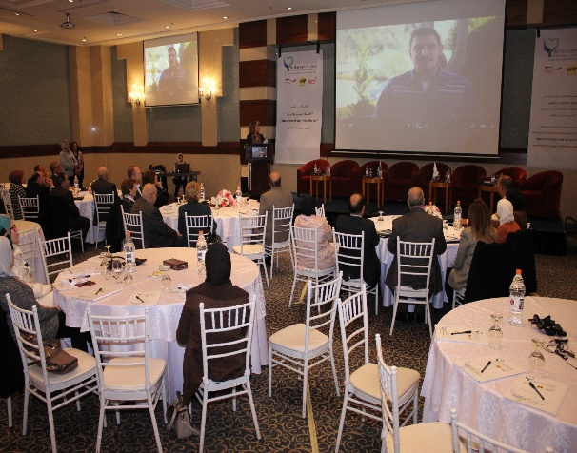

# IOCC- International Orthodox Christian Charities

In cooperation with IOCC Society two training courses on CBR were held as follows:

1. In the Azraq Camp, training course was held for **12** trainees (Syrian refuges+ Jordanian) about CBR programs (The duration of the course was five training days).
2. In Amman, a training course was held for **47** trainees: Syrian refuges and Jordanians (including CBRWs from Sweileh, Zarqa, and from Al Russeifa, project staff, representatives from ministries at the Amman and Zarqa directorate levels, and relevant invited (The duration of the course was four training days).

* Final reports on CBR training were submitted to IOCC.

# Humanity Aid and Development Cooperation (ACTION –Medeor)

* Agreement was signed with Medeor to improve the rehabilitation services at AHS through providing AHS with rehabilitation equipment, PT capacity building and support AHS attendance in international conferences.
* 2nd shipment of donated equipment to be used at the rehab program has been delivered.
* Training of AHS rehab was held by Medeor on Galileo rehab.
* AHS staff attended “Early Intervention and treatment approach for children with HCSB and other neurological impairments”.
* **104** PWDs and elderly people have registered to receive rehab sessions with the help of new devices.
* **2** PTs participated in the study visit to the Rehabilitation Center of UniReha GmbH – from 17th till 27th of May 2019 in Germany.
* **9** Rehab experts together with 23 beneficiaries attended "Unconditional Giving Day" to promote the project activities. University professors and medical doctors from the Ministry of Health attended the event where the project equipment specially the Galileo unit were introduced to them by AHS rehab advisor. Open discussions followed the event among the professors and the medical doctors discussing the future of the project and how to invest in the project activities. Furthermore, AHS services in general and project activities in specific were promoted to the community.
* Final Narrative Report was submitted to Medeor.
* Clearance requirements of an accessible vehicle by Medeor has been followed in cooperation with HRH Princess Majda. This required to deal with this as new separate project that needs to have the approval of all the concerned ministries.

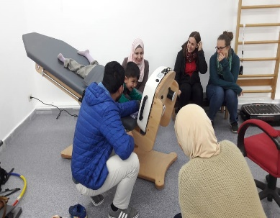

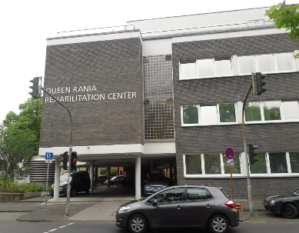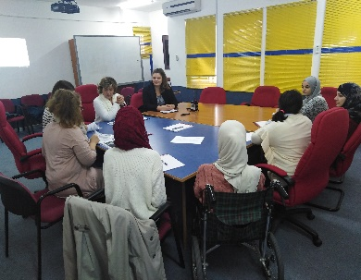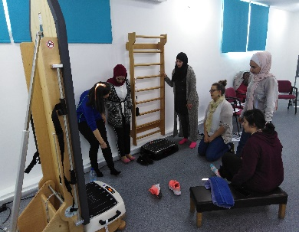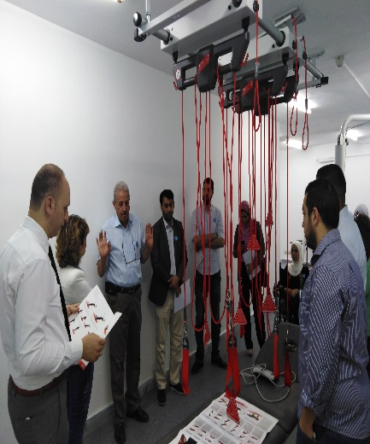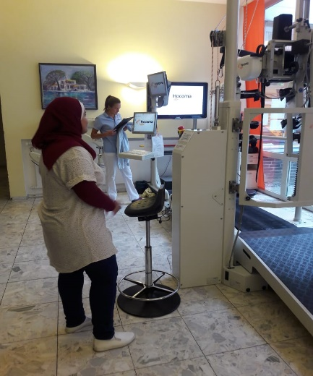

# CLASP Consolidated Logistics for Assistive Technology Supply for Assistive Technology Supply and Provision

* New agreement was made between AHS and Clasp to provide AHS with wheelchairs and Mobility Aids for 2018 / 2019 after passing three tests under the Project: “Improve the availability of and access to appropriate assistive technology in less resourced settings and to promote quality service provision”.
* 147 wheelchairs and mobility aids were distributed.
* A new agreement for the year 2020 has been signed to receive specialized wheelchairs for the amount of $20,000.
* 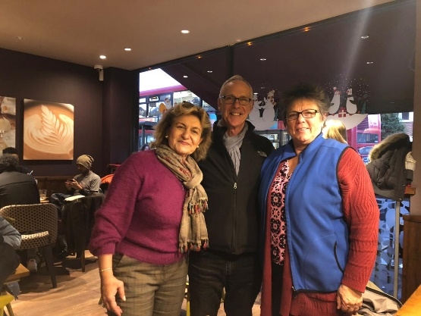Two meetings were held with CLASP project team in London for two days: one before the international security conference and one during the conference to discuss future cooperation at the regional level between UCP Wheelchair (The grant holder of CLASP project) and AHS. An MOU will be prepared in this respect.

# Orange Jordan: Mobile Phones and wireless internet service

**An agreement was signed between AHS and Orange Company to support AHS in establishing comprehensive rehab services as income generating project**.

* A delegation from Orange Company visited AHS to review the actions taken by AHS to establish the PT center.
* Statistical and narrative reports were submitted reflecting the process.
* PT work license has been followed and eventually issued.

# Embassy of Ireland

* The Irish Ambassador visited AHS to discuss future cooperation and support AHS programs. Two projects were proposed: One in the amount of JD 8000 that will be used to maintain the buses and the other for the amount of JD 4500 to provide AHS with necessary equipment to train those working in the field of rehab.
* A meeting was held at the Irish Embassy with the Ambassador to discuss project proposals and their requirements.
* Maintenance and upgrading AHS buses were successfully implemented.

# ZERO PROJECT

AHS submitted program “Innovative Approach towards Inclusive Education: Leaving no one behind” has been selected as an Innovative Practice of the Zero Project 2020.

ED will present the work at the Zero Project Conference at the United Nations in Vienna, in February 2020, in front of experts and leaders in the field of disability from all around the world.

# Johanniter’s

ED participated 3 days of Johanniter’s regional partners meeting.

The outcomes of the meeting were:

1- Revision JIA Country Strategies- Jan 2020.

2- Agreement to establish regional consortium- March 2020 on inclusive education including partners from Syria, Lebanon, Jerusalem, Iraq, and Jordan headed by AHS.

# New Local and International Agreements

* Signing the MOU between the MGH Institute of Health Professions, Inc Massachusetts not-for-profit Corporation, Boston, and Al Hussein Society, The MGH Institute and AHS hereby agree that this Agreement concerns CEEs for students enrolled in only those Institute program(s) specifically agreed to between the parties.
* Research Cooperation between University of Jordan and AHS “Activating the use of a medical record for children with cerebral palsy at AHS”.
* MoU between Al Hussein Society Jordan Center For Training & Inclusion and The Jordan University of Science and Technology; the parties have agreed as follows: AHS and JUST intend to contribute, each for the specific sector of competence, to the implementation of the research project “Therapeutic effect of transcranial direct current stimulation on gait patterns in children with diplegic cerebral palsy**.**

# Local and International Exposure/ Participation in Local and Regional Events

**AHS Executive Director presented scientific papers at the following international conferences**:

* ATIA conference for Assistive Technology in Orlando and submitted a paper with title: “Longitudinal case study: The Effects of Introducing Assistive Technology Solutions”.
* Regional Symposium on Trade Union Work to Provide Decent Work for People with Disabilities
* Submitted a paper about the role of AHS on CBR during a workshop that was organized by MGH Institute of Health Professions / Toward an All – Inclusive Jordan.
* Presented scientific paper at the conference entitled: “Innovative Approach towards Inclusive Education: Leaving no one behind” at the International Scientific Conference in Special Education at the Hashemite University entitled “Accessibility to Knowledge Content for Persons with Disabilities”.
* Knowledge content of persons with disabilities organized by the Hashemite University.
* ED conducted a workshop on the role of institutions and the local community in the community-based rehabilitation program at Al Talbyeh CBR center.
* ED attended a the workshop about: MENA launch of the Sphere Handbook on Tuesday, 11 June 2019 at 2 pm. organized by Deutsche Botschaft Amman / Embassy of the Federal Republic of Germany
* ED attended the workshop about Go-MENA Inclusion Work Stream, on the topic of: Implementation of the LNOB principle of the agenda 2030- through Disability Inclusive Development Approaches in GIZ programs in the Mena region / - organized by Civil Society Programme / CSP.
* ED attended a workshop with the title (Guidance for Rehabilitation Strategic Planning) which was held on 28th and 29th of July 2019, to develop a national rehab strategy.
* Several meetings with GIZ have been held to discuss the inclusive education and school assistant services.
* ED attended the Global Conference on Assistance to Victims of Anti-Personnel Mines and Other Explosive Remnants of War, and Disability Rights.
* ED attended the closing session of the Master Program on Clincial Rehab at JUST University where she was asked to be part of the closing panel and share her remarks.
* ED with four psychologists and teacher facilitated GIZ ran stakeholder meeting: Securing the future of assistive services in Jordan: Challenges and Policy Recommendations. ED presented the outcomes of the meeting in front of the MOE Education Director and BMZ Development Councilor at the German Embassy.
* ED attended the Global Conference on “IDR Exhibition in London. ED held a meeting with Ms. Leesa, UCPW’s Director of Finance and Operations and Elizabeth “CLASP”.
* ED attended Launching ceremony for the national plan of correcting building situations. The ceremony was organized by the Higher Council under the patronage of Prime Minster Dr. Omar Al Razzaz.
* ED attended “Inclusive Education and Employment in Jordan”. The workshop took place in Geneva Hotel, on 1st and 2nd of April. The workshop focused on Inclusion in Education, TVET and Employment in the Jordanian setting and is planned to also include our partner organizations.
* ED attended short presentation on "The new Regional Governments' Responses to the Syrian Refugee Situation in: Turkey, Lebanon, and Jordan” prepared by ZFD Forum: Civil Peace Service.
* ED attended a meeting at Queen Rania Faculty for childhood after she was chosen by the President of the University as a member of the Faculty Council.
* ED and AHS team visited ICMC in Al Mafraq to know more about their program which is a child-friendly educational and reactional space.
* ED had a meeting with Dr. Osama Obeidat, CEO of Queen Rania Teacher Academy to discuss, future plan in empowering AHS school teachers, special educators and OTs.
* A meeting was held with Vice President of HU Dr. Ali Al Karmi and the Dean of Rehabilitation Faculty Dr. Mahmoud Abu Ghosh to discuss the preparations of CBR Diploma.
* ED attended 100 years’ anniversary celebrations of the International Labor Organization.
* BMZ regular roundtable meetings together with their implementing partners was held at AHS. All the NGOs who are funded by the German Government attended the meeting and discussed future cooperation at different levels. AHS and World Vision presented their programs that were subjects for discussion.
* A delegation from Princess Basma Foundation in Jerusalem visited AHS - with the aim of networking, future cooperation and exchange of experiences. Visit to Jordan Academy for Autism has been arranged and a meeting with HRH Princes Majda was held.
* A delegation from Germany visited AHS: Vice Prime Minister and Minster for children, family, refugees and Integration Dr. Joachim Stamp, accompanied by his secretary of state for integration Ms. Serap Gueler and Secretary of state for International Affairs Dr. Mark Speich from Prime Minister’s state Chancellery.
* AHS participated at the International Scientific Conference in Special Education at the Hashemite University entitled "Knowledge content of persons with disabilities” ED presented scientific paper at the conference entitled: Innovative Approach Towards Inclusive Education: Leaving no one behind
* AHS school graduation ceremony was held on Monday June 10th.
* Inclusive Summer Camp Activities started July 21, 2019, till August 20th.
* Preparations for Musical performance presented by Irish group organized by the Irish Embassy.
* AHS multidisciplinary team visited the Noor Al-Hussein Foundation to be familiar with the activities and programs and identify aspects of cooperation and coordination between AHS and NHF.
* AHS students accompanied by the staff participated in the ICS Art exhibition.
* AHS students went on educational trips.
* AHS students participated in many activities including:
* Eid al Fiter & Adha celebrations & Prophet Mohammad’s Birthday.
* Christmas celebration.
* Music classes continued at the school by the music therapist Ms. Sahar Khalifeh.

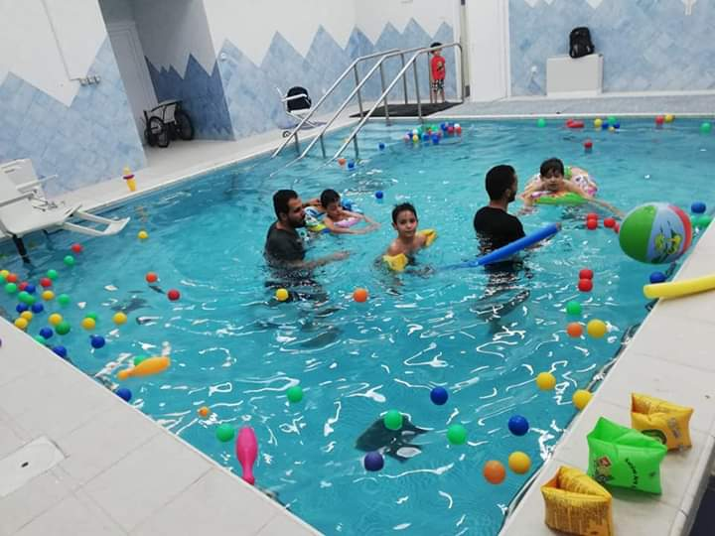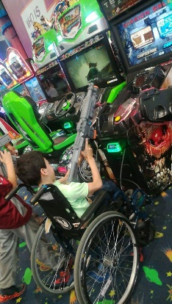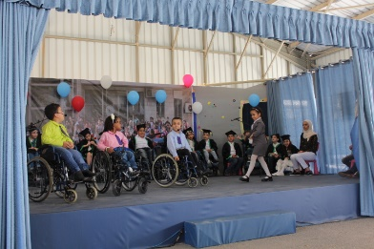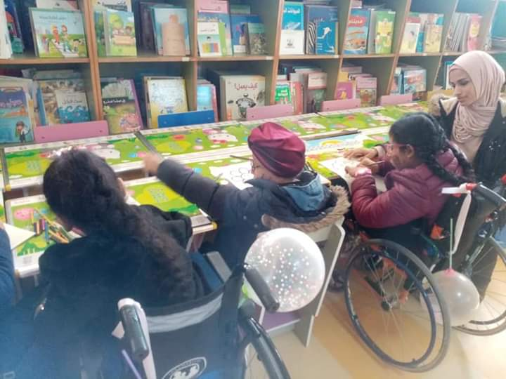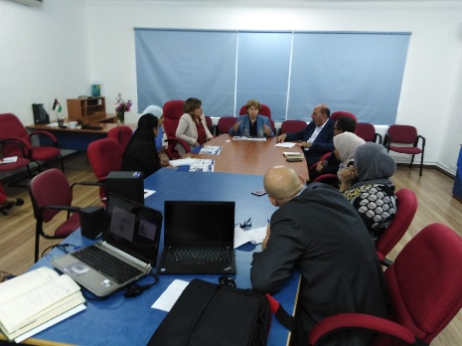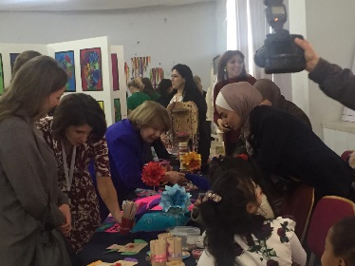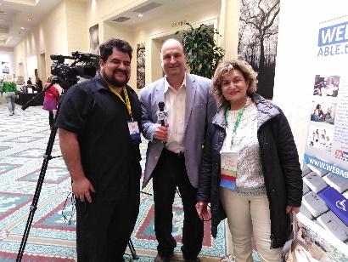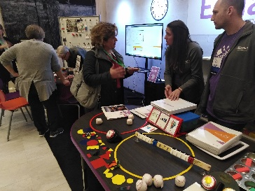

# New Policies and Procedures

* Students' integration process and procedures were reviewed and standardized based on checklist.
* Training materials were revised to meet the needs of the parents.
* Nursery protocols and programs were revised and updated to meet local rules and regulations to include the psychological aspect.
* AHS organizational structure was modified and the responsibilities were re-distributed among the seniors.
* Several meetings with AHS staff have been conducted by ED to discuss the inclusive education at AHS and the following actions were taken in this respect:
* Two committees have been established to supervise inclusive education processes: Technical and administrative and support the school principle.
* The school children were redistributed among the different classes based on their intellectual, behavioral and physical needs.
* The teachers were re-distributed based on their credentials to meet the needs of each class room.
* The curriculum was simplified to meet the needs of the children while achieving the same outcomes.
* Assessment tools modified according to the potentials of the children rather than relying on their performance.
* Client satisfaction has been continuously followed.
* TACTIX new management has been approached to continue their support which has been done for the past two months.
* Financial Manager developed a protocol for acknowledging different AHS sponsors.
* New uniforms were designed and ordered for all the rehab staff.
* Every single operation is to be supported with protocols to be uploaded into the enterprise Resource Planning automated system to ensure sustainable quality deliverables.
* 2019 annual plan was developed based on 2018 situation analysis.
* Parents training workshops were organized: Inclusion, PWDS rights, Safe environment for children.
* Safeguarding workshop for AHS employees was held to disseminate child safeguarding code of conducts.
* Internship program was introduced and activated to fill the gaps of the available vacancies and minimize activities.
* All the PT and OTs technical performances were assessed by Dr. Hikmat.
* All the assessment forms were reviewed by Dr. Hikmat and adopted by the staff.

# Statistical Report on Rehabilitation Services

### - **Early Intervention Program (EIP)**

|  |  |  |
| --- | --- | --- |
|  | Service Categories | Total |
| 1. | **Number of beneficiaries** | 76 |
| 2. | **Screening session** | 180 |
| 3. | **Group therapy** | 4 |
| 4. | **Individual family training session** | 1747 |
| 6. | **Hydrotherapy** | 58 |
| 7. | **P&O appointment for device repair** | 18 |
| 8. | **Co-session** | 3 |
| 9. | **Medical clinics- orthopedic, Neuro-pediatric** | 21 |
| 10. | **Serial Cast** | 8 |
| 11 | **Electrical sessions** | 65 |
| 12 | **Galileo sessions** | 92 |
| 13 | Care giver support | 33 |

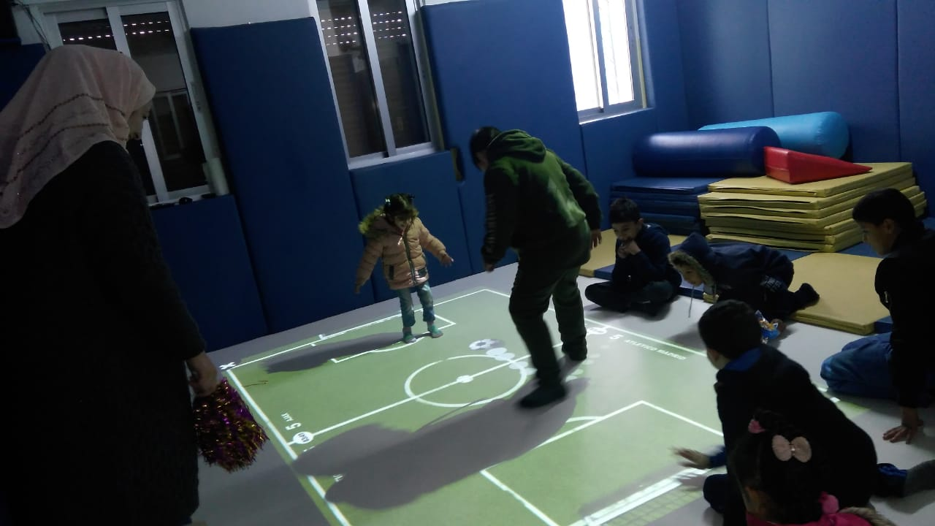

Beneficiaries under **3** years of age who attended EIP represent **58%** of the total number of new EIP beneficiaries.

### **Outreach Program / (CBR)**

|  |  |  |
| --- | --- | --- |
|  | Service Categories | Total |
|  | **Client served at the centers** | 50 |
|  | **Client served outside the centers (home visits )** | 33 |
|  | **Number of distributed adapted mobility aids** | 1349 |
|  | **Number of volunteers trained** **about CBR strategy** | 32 |
|  | **Courses & workshops for volunteers** | 1 |
|  | **Community awareness lectures (centers, schools).** | 5 |
|  | Number of beneficiaries attending awareness lectures | 258 |

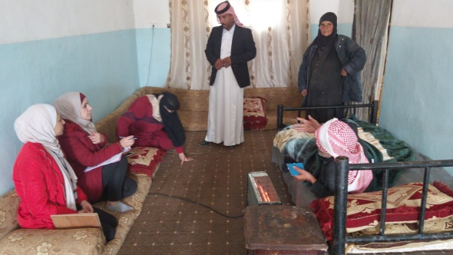

### **Areas Serviced by Outreach Program**

|  |  |  |  |  |  |  |  |
| --- | --- | --- | --- | --- | --- | --- | --- |
| Location | Amman | Maan | Al Tafeleh | Irbid | Al Mafraq | Azraq Camp | Al Zarqa |
| Number of beneficiaries | 80 | 25 | 42 | 102 | 75 | 200 | 40 |

### **Mobile Clinic**

|  |  |  |
| --- | --- | --- |
| Beneficiaries | Area | Mobility aids distributed:  (wheelchairs, walkers, crutches, …) |
| PWDs “Refugees and Jordanians” | Amman, Azraq Camp, Irbid, Al Tafeleh, and Maan | 1349 mobility aids distributed through 35 mobile clinics |

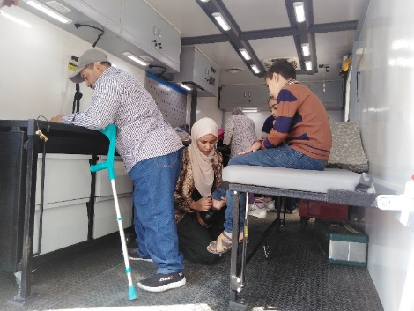

### **Physical Therapy Program**

|  |  |  |
| --- | --- | --- |
|  | Service Categories | Total |
|  | **Assessment sessions** | 117 |
|  | **Group therapy** | 41 |
|  | **Individual sessions** | 1736 |
|  | **Individual family training sessions** | 6 |
|  | **Family training meetings and workshops** | 3 |
|  | **Hydrotherapy** | 223 |
|  | **Co-sessions** | 16 |
|  | **Referrals to the clinic (Ortho, Neuro, Spinal cord)** | 63 |
|  | **Serial castings** | 15 |
|  | **P&O appointments for device measurement** | 40 |
|  | **Out patients** | 23 |
|  | **Rehabilitation meetings** | 56 |
|  | **Electrical sessions** | 14 |
|  | **Galileo sessions** | 126 |
|  | Sport sessions | 243 |

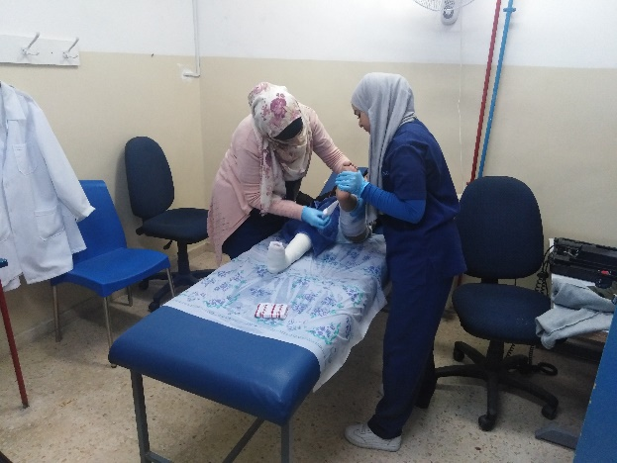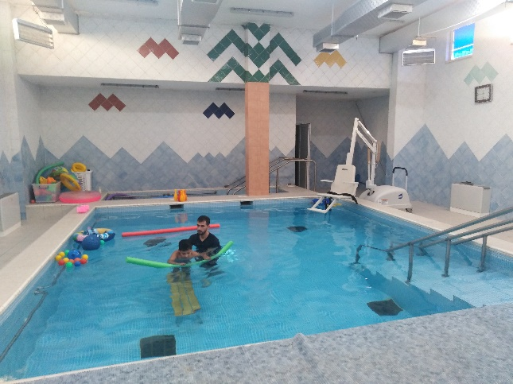

### **Occupational Therapy Program**

|  |  |  |
| --- | --- | --- |
|  | Service Categories | Total |
|  | **Screening sessions** | 102 |
|  | **Evaluation "Assessment"** | 65 |
|  | **Group therapy** | 67 |
|  | **Individual session** | 1261 |
|  | **Classroom adaptations** | 140 |
|  | **Class Room Attendance** | 482 |
|  | **Splinting** | 6 |
|  | **Wheelchair adaptations and Maintenance** | 48 |
|  | **School integration visits** | 20 |
|  | **Community –based visits** | 4 |
|  | **Rehabilitation meetings** | 70 |
|  | **Family training** | 3 |
|  | **Provision of mobility aids** | 118 |
|  | Co-management Sessions | 12 |

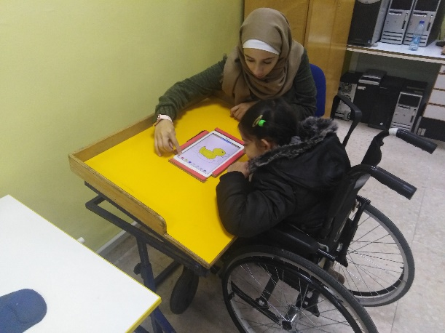

### **Nursing Program**

|  |  |  |
| --- | --- | --- |
|  | Service Categories | Total |
|  | **Management of sores** | 74 |
|  | **Bowel training** | 2086 |
|  | **Bladder training** | 2408 |
|  | **Caregiver support group training- workshops** | 7 |
|  | **Follow-up surgeries** | 10 |
|  | **Rehabilitation meetings** | 26 |
|  | **Medical clinics** | 252 |
|  | **Personal hygiene sessions** | 772 |
|  | **Class Sessions** | 15 |
|  | **Follow up hydrotherapy** | 181 |
|  | Hippo therapy | 17 |

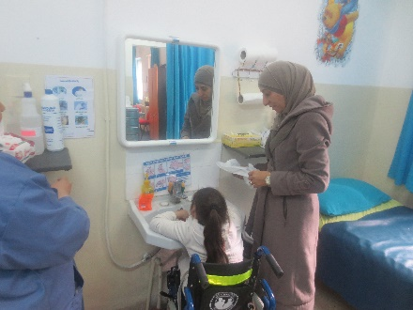

### **Orthopedic Engineering Program**

|  |  |  |
| --- | --- | --- |
|  | Service Categories | Total |
| 1. | **Rehabilitation clinics** | 112 person through 49 rehab & Orthopedic clinics |
| 2. | Number of manufactured medical braces | 151 devices |

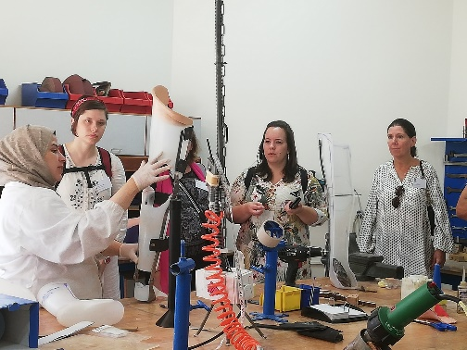

### **Mobility Aids Maintenance and Adaptation Workshop**

|  |  |  |
| --- | --- | --- |
|  | Service Categories | Total |
|  | **Wheelchair adaptations** | 267 |
|  | **Wheelchair maintenances** | 196 |
|  | **Maintenance of CP wooden chairs** | 15 |
|  | **Maintenance of classroom tables** | 64 |
|  | **Maintenance of AHS furniture** | 14 |
|  | **Adaptation of the school buses** | 8 |
|  | Mobile clinic participation | 35 |

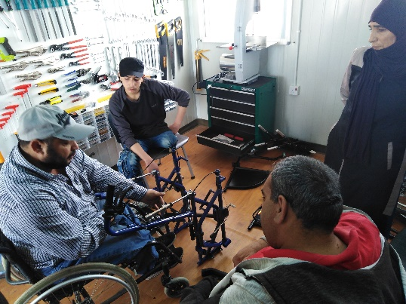

### **School**

|  |  |  |
| --- | --- | --- |
|  | Service Categories | Total |
|  | **Classroom sessions** | 8400 |
|  | **Smart board sessions** | 5600 |
|  | **Music sessions** | 320 |
|  | **Computer sessions & assistive technology sessions** | 240 |
|  | **Educational visits (Outside AHS)** | 1 |
|  | **Library sessions** | 50 |
|  | **Sport Sessions** | 240 |
|  | **Parent-Teacher meeting "Rehab meeting"** | 1 |
|  | **Individual parent-teacher meetings** | 30 |
|  | **Community service program/number of students from outside schools** | 5 |
|  | Number of volunteers | 4 |

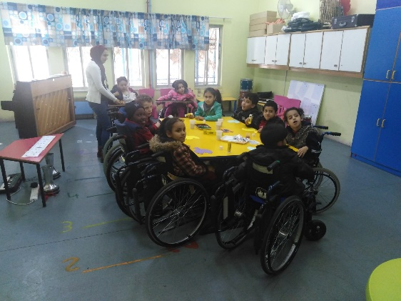

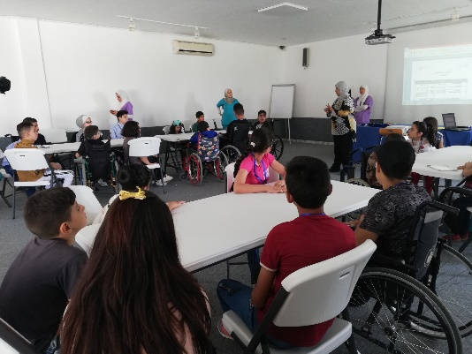

### **Psychosocial Counseling Department**

|  |  |  |
| --- | --- | --- |
|  | Service Categories | Total |
|  | **Individual sessions family meeting** | 535 |
|  | **Support groups with students** | 55 |
|  | **Screening sessions (Stanford-Binet)** | 74 |
|  | **Social studies** | 93 |
|  | **Individual sessions with students** | 541 |
|  | **Classroom group sessions** | 151 |
|  | **Family counseling sessions** | 23 |
|  | **Rehabilitation meetings** | 71 |
|  | **Child abuse treatment/individual sessions for children** | 9 |
|  | **Child abuse treatment/ individual sessions for families** | 11 |
|  | **Child Reinforcement** | 316 |
|  | **Training courses** | 16 |
|  | **Community Integration visit (outside AHS)** | 5 |
|  | **Group counseling** | 39 |
|  | **Number of families who have signed the code of conduct to protect children from abuse** | 64 |
|  | **Number of AHS staff who have signed the code of conduct to protect children from abuse** | 36 |
|  | Number of university students who have signed the code of conduct to protect children from abuse | 133 |

### **Speech Therapy**

|  |  |  |  |
| --- | --- | --- | --- |
| Service Categories |  | | |
| **EIP** | **School** | **Outpatients** |
| Number of beneficiaries | **22** | **38** | **5** |
| Evaluation sessions | **25** | **85** | **5** |
| Individual sessions | **326** | **220** | **0** |

### **Quality and training**

### **Integration**

|  |  |  |
| --- | --- | --- |
|  | Service Categories | Total |
| 1. | **Follow-up school visits (All-integrated Students)** | 19 |
| 2. | **Meetings with parents** | 1 |
| 3. | **Workshop with the Ministry of Education** | 1 |
| 4. | **Meetings with school's headmasters and counsellors** | 20 |
| 5. | **Private meetings with parents** | 25 |
| 6. | **Counselling lectures for students in integrated classes** | 15 |
| 7. | **Public schools with integrated students** | 8 |
| 8. | **Private schools with integrated students** | 5 |
| 9. | UNRWA schools with integrated students | 1 |

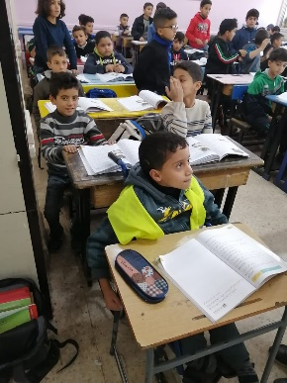

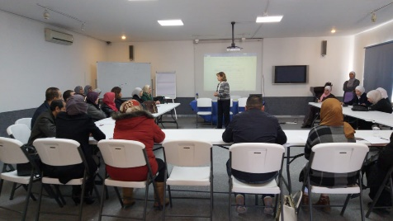

### **Training**

### **University Students Training**

|  |  |  |  |
| --- | --- | --- | --- |
|  | University | Type of training | Total |
| 1. | **Jordan University** | **Clinical Training for 4th year Occupational Therapy and Physiotherapy students** |  |
|  | **Isra University** | **Clinical Training for Physical Therapy students** | 8 |
| 2. | **Hashemite University** | **Clinical Training for Occupational Therapy students & Physical Therapy students** | 101 |
|  | Total | | 278 |

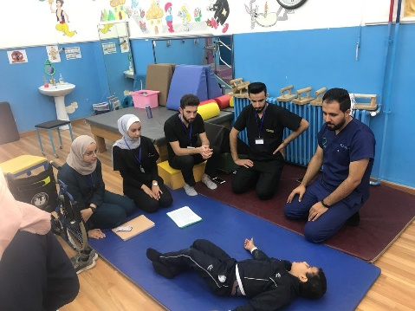

### **Family Training**

|  |  |  |
| --- | --- | --- |
|  | Service Categories | Total |
| 1. | **Number of conducted training workshops** | 5 |
| 2. | Number of attending families | 147 |

### - **Capacity-Building Activities**

|  |  |  |  |  |
| --- | --- | --- | --- | --- |
|  | Course Title | # of Participants | Duration | Organizer |
|  | **Stanford Binet version 5** | **8** | **2 weeks** | Bana Center |
|  | **Assessment of children with CP and their recording on a national platform** | **12** | **1 day** | Prof. Nihad Al Masri.  Jordan University |
|  | **Galileo Rehab** | **6** | **5 days** | Medeor  UniReha from Cologne |
|  | **Early Intervention and treatment approach for children with HCSB and other neurological impairments** | **9** | **5 days** | Ms. Regina Zulianello |
|  | **Study visit to the Rehabilitation Center of UniReha GmbH- Germany** | **2** | **10 days** | Rehabilitation Center of UniReha GmbH |
|  | **Upya Orthosis** | **2** | **1** | Jordan University |
|  | **Music as a Teaching Strategy in the Classroom** | **20** | **1** | AHS |
|  | **Child Safeguarding** | **51** | **1** | AHS |
|  | **Methods to treat spasticity in children** | **3** | **1** | Prof. Mohammad Ozik- Turkey |
|  | **Serial Casting** | **10** | **1** | AHS |
|  | **Cognitive problems of children in school setting** | **7** | **1** | AHS |
|  | **GMAE - (Gross Motor Ability Estimator)** | **7** | **2** | Dr. Hekmat |
|  | **Denver II: Developmental Screening Test (Day One to Six)** | **18** | **2 h** | Dr. Hekmat |
|  | **International classification Function - ICF** | **24** | **1** | Dr. Hekmat |
|  | **Safe Guarding Environment** | **51** | **1** | AHS |
|  | **General Safety Procedure** | **51** | **1** | AHS |
|  | **Confidentiality of Information** | **51** | **1** | AHS |
|  | **Purchasing Policies** | **51** | **1** | AHS |
|  | **Role of Speech Therapist in Rehabilitation** | **16** | **1** | AHS |
|  | **AHS Strategy** | **51** | **1** | AHS |
|  | **Educational Strategies** | **31** | **1** | AHS |
|  | **Inclusive Education** | **16** | **1** | AHS |
|  | **Mental Health** | **27** | **1** | AHS |
|  | **The role of OT in inclusive education** | **22** | **1** | AHS |
|  | **Low back pain and its management** | **27** | **1** | AHS |
|  | **Self-Development** | **55** | **1** | Dr. Ashraf Al Salhi |
|  | **Psychosis** | **30** | **1** | AHS |
|  | Emotional and Social Development Support of Children | 30 | 1 | Sirsa Qursha |

### **Information Technology**

|  |  |  |  |
| --- | --- | --- | --- |
|  | Service Category | | Total |
|  | | **Software prepared by the IT manager** | 3 |
|  | | **Maintenance of computers and other equipment** | Daily-upon request |
|  | | **Database backups and maintenance** | daily |
|  | | **Back-up for AHS computers** | Servers |
|  | | **Computer sessions & assistive technology sessions** | 240 |
|  | | **Network security** | Daily |
|  | | **DVRs** | Daily |
|  | | **ERP System infrastructure and support** | Upon request |
|  | | **Trainings/Events technical preparations** | 8 |
|  | | Multimedia | Upon request |

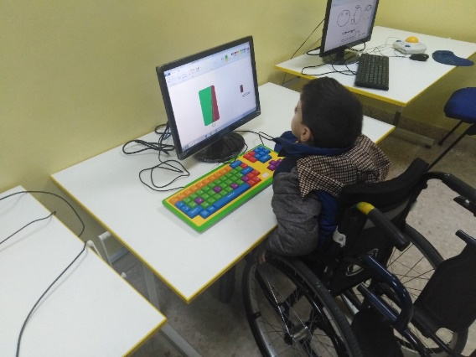

# AHS Contribution for Persons with Disabilities at National Level

The total number of AHS services provided during **2019** amounted to **4030** beneficiaries as clarified in the table below:

|  |  |  |
| --- | --- | --- |
| No of beneficiaries | Service's |  |
| 92 | **Academic Education - inclusive education** | **1.** |
| 76 | **Early Intervention Program (EIP)** | **2.** |
| 17 | **Integration / Public & Private schools** | **3.** |
| 43 PWDs  184 sessions have been carried out | **Outreach& CBR programs, PT, OT, and Counselling Sessions** | **4.** |
| 1761 | **Mental health services: provided dispensing medications & psychological rehabilitation sessions** |  |
| 151 | **Medical Devices / Orthotic Braces and Prosthesis** | **5.** |
| 496 Persons received 822 mobility aids | **Distribution of adapted Mobility Aids** | **6.** |
| 196 | **Mobility aids maintenance** | **7.** |
| 278 | **Training of university students** | **8.** |
| 147 | **Training of Family / Empowering care givers** | **9.** |
| 364 | **Medical Clinics** | **10.** |
| 88 | **Training of field workers** | **11.** |
| 284 | **Number of persons attended awareness-raising workshops on the rights of persons with disabilities and available services.** | **12.** |
| 37 persons through 28 places were adapted | **Number of persons directly benefited from the adaptation of the facilities that AHS had adapted its environment - Accessibility** | **13** |
| 4030 | **Total** |  |

This report provides only a glimpse of the qualitative impact of AHS. Through solid rehabilitation services, AHS contributes in raising awareness and advocating the rights of persons with disabilities on a national level.

# Future Plans

* Implement activities and programs to become a regional training center as part of the **5** Year Strategic Plan (2017-2021).
* Provide comprehensive rehab services for all as income generating project.
* Renew old buses for AHS children & students.
* Renovate the infrastructure to maintain the services.
* Establish conference room & research labs.
* Activate sponsorship program.
* Increase the AHS sponsors' base.

# Acknowledgements

**Th**a**nk You**

Al Hussein Socety extends its sincere gratitude and appreciation to all those, who supported its mission during 2019 and to the Diplomatic Missions and the International Women Associations , who participated in the Annual Bazaar as well as to the numerous contributors to our vintage shop “New to You”. Special thanks also goes to our supporters / partners:

**Royal Hashemite Court**

**Princess Nissa Raad**

**Higher Council for the Rights of Persons with Disabilites**

**Ministry of Social Development**

**Ministry of Education**

**Ministry of Health**

**Ministry of Communications and Information Technology**

**Ministry of Labor**

**Ministry of Planning & International Cooperation**

**Greater Amman Municipality**

**Hashemite University**

**JUST University**

**University of Jordan**

**Isra University**

**C B M**

**BMZ**

**IOCC**

**HELP International**

**Action Medeor**

**Jordan Humanitarian Fund-United Nations Office for the Coordination of Humanitarian Affairs (OCHA), Jordan**

**Center for Cultural & Educational Affairs for the Church of Jesus Christ of Latter-day Saints -(LDS)**

**CLASP**

**Ireland Embassy**

**Orange**

**DunesClub / Amman**

**TactiX Strategic Consulting**

**Zain Employees**

**Jubran restaurant**

**Suha Shoman & Family**

**Messrs. Shawi, Rsheidat & Massanat Company**

**Amman Acdemy**

**InterContinental Jordan**

**International Community School**

**Nouran Kirdar**

**Iyad Musbah**

**Othman Bdeir**

**Basma Bisharat**

**Bert & Sara DeVries**

**Jenna Morton Family**

**Hasan Sobhi Al Haj Hasan**

**Maher & Samer & Loli Anis Muasher**

**Zeina Said**

**Tareq Al Kurdi**

**Abla Kawar**

**Hasan Alawi**

**Sara Mango & Riad Dajani**